1)Write a Java program that takes a list of integers as input and returns a list of duplicate integers.

**package** org.collection.assignment;

**import** java.util.*;

**public** **class** LinkedListDuplicates {

**public** **static** **void** duplicateList(List<Integer> list) {

List<Integer> duplicates = **new** ArrayList<>();

**for**(**int** i=0; i< list.size(); i++) {

Integer iElement = list.get(i);

**for**(**int** j=i+1; j<list.size(); j++) {

Integer jElement = list.get(j);

**if**(iElement.equals(jElement)) {

**if**(!duplicates.contains(iElement))

duplicates.add(iElement);

**break**;

}

}

}

System.***out***.println("\nDuplicate Elements are : ");

**for**(Integer dupl : duplicates)

System.***out***.print(dupl + " ");

}

**public** **static** **void** main(String[] args) {

Scanner sc = **new** Scanner(System.***in***);

List<Integer> list = **new** ArrayList<Integer>();

System.***out***.println("Enter elements of list : ");

list.add(sc.nextInt());

list.add(sc.nextInt());

list.add(sc.nextInt());

list.add(sc.nextInt());

list.add(sc.nextInt());

System.***out***.print("\nList elements are : ");

**for**(Integer element : list)

System.***out***.print(element + " ");

// List of Duplicate Integers

*duplicateList*(list);

}

}

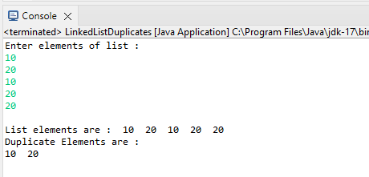

2)Create a Person class with attributes name and age. Write a Java program that sorts a list of Person objects first by age and then by name if the ages are equal.

**package** org.collection.assignment;

**import** java.util.*;

**class** Person{

String name;

**int** age;

**public** Person() {

}

**public** Person(String name, **int** age) {

**this**.name = name;

**this**.age = age;

}

**public** String toString() {

**return** String.*format*("%-10s%-3d", **this**.name, **this**.age);

}

}

**class** AgeComparator **implements** Comparator<Person>{

**public** **int** compare(Person p1, Person p2) {

**return** p1.age - p2.age;

}

}

**class** NameComparator **implements** Comparator<Person>{

**public** **int** compare(Person p1, Person p2) {

**return** p1.name.compareTo(p2.name);

}

}

**public** **class** PersonCollection {

**public** **static** **void** display(Collection<?> list) {

**for** (Object p : list) {

System.***out***.println(p.toString());

}

}

**public** **static** **void** main(String args[]) {

List<Person> list = **new** ArrayList<>();

Person p1 = **new** Person("Shreeram", 27);

Person p2 = **new** Person("Ashish", 25);

Person p3 = **new** Person("Ganesh", 23);

list.add(p1);

list.add(p2);

list.add(p3);

System.***out***.println("List of Elements : ");

**for**(Person p: list)

System.***out***.printf("%-10s%-3d\n", p.name, p.age);

System.***out***.println("\nSort by Age : ");

Collections.*sort*(list, **new** AgeComparator());

*display*(list);

System.***out***.println("\nSort by Name : ");

Collections.*sort*(list, **new** NameComparator());

*display*(list);

}

}

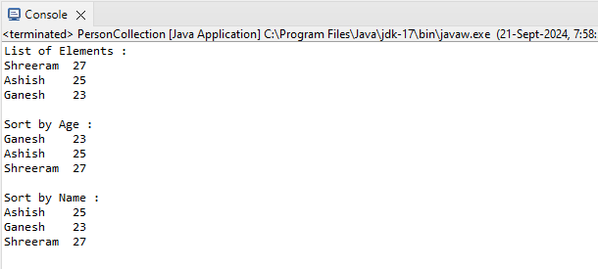

3)Write a Java program to find the first non-repeated character in a string using a HashMap.

String input = "aabbccddeffg";

Expected output = 'e';

4) Write a Java program that merges two sorted lists of integers into a single sorted list.

**package** org.collection.assignment;

**import** java.util.*;

**public** **class** SortedArray {

**public** **static** **void** display(Collection<?> list) {

**for**(Object element : list)

System.***out***.print(element + " ");

}

**public** **static** **void** main(String[] args) {

List<Integer> list1 = **new** ArrayList<>();

list1.add(100);

list1.add(80);

list1.add(20);

list1.add(60);

list1.add(40);

List<Integer> list2 = **new** ArrayList<>();

list2.add(70);

list2.add(30);

list2.add(90);

list2.add(10);

list2.add(50);

System.***out***.println("Sorted List1");

Collections.*sort*(list1);

*display*(list1);

System.***out***.println("\nSorted List 2");

Collections.*sort*(list2);

*display*(list2);

list1.addAll(list2);

System.***out***.println("\nSorted Combined List Elements :");

Collections.*sort*(list1);

*display*(list1);

}

}

